**Task No. 1:** Perform all the commands provided in the lab manual.

**Solution:**

* **Command: find . -iname “*.c”**

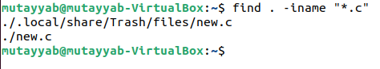

* 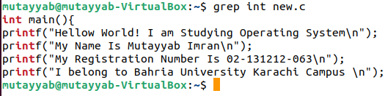**Command:** **grep int file.c**
* **Command: grep “int main” file.c**
* 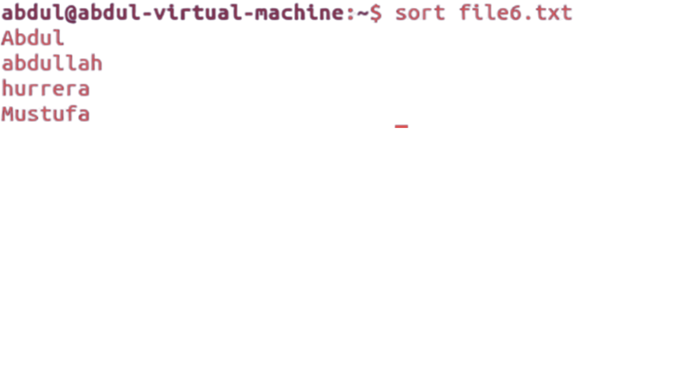**sort filename.txt screen**
* 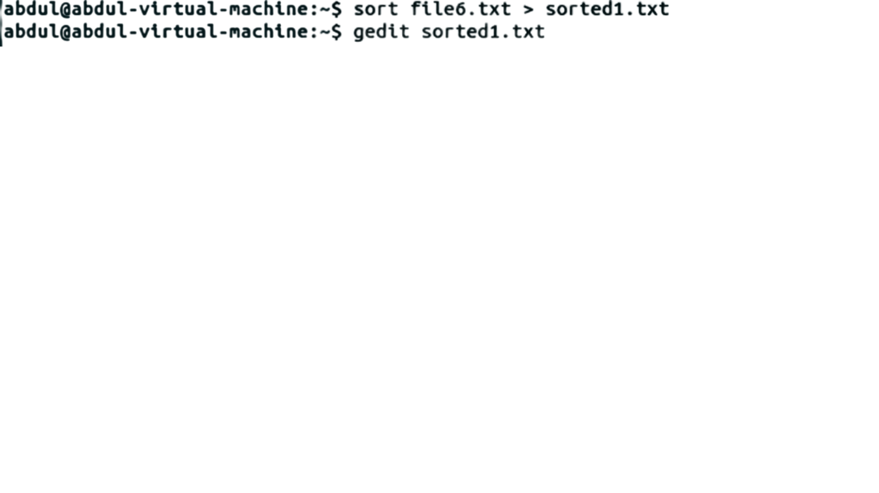**Command:** **sort filename.txt > sorted.txt**

**LAB Example**

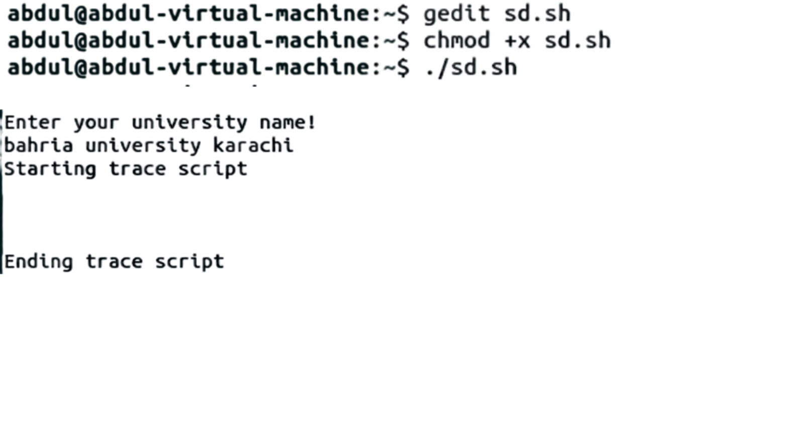

**Task No. 2:** Create an empty file with a .txt extension. Write a shell script that would write the current date, student’s name and registration number into that file, while using variables for all three entries.

**Solution:**

#!/bin/bash

echo "Enter Your Name : "

echo "Enter Your Name : " > output.txt

read var0

echo "Name is $var0" >> output.txt

echo "Enter Your Registration No : "

echo "Enter Your Registration No : " >> output.txt

read var1

echo "Registration # : $var1" >> output.txt

echo "Current Date :"

echo "Current Date :" >> output.txt

echo "$(date +%F-%T)" >> output.txt

**Output:**

**Task No. 3:** Create a .txt file and input ten lines of entry while mixing it with both alphanumeric characters. Sort the contents of the created file in an ascending order and write the sorted output into another file.

**Solution:**

**:**

**Task No. 4:** write a Program to Sum of Natural Numbers Using for Loop

**Solution:**

#include<stdio.h>

int main(){

int number,sum=0;

printf("Enter any Natural Number : ");

scanf("%d",&number);

for(int i=0;i<=number;i++){

sum+=i;

}

printf("Answer of %d is %d \n",number,sum );

return 0;

}

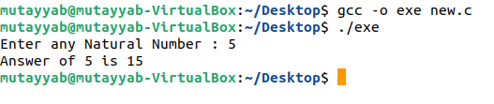**Output:**